SUPPLEMENTARY MATERIAL

CONTENTS:

- Dopaminergic medication
- Pre-processing and analysis of fMRI images
- Head movements during fMRI scanning
- Regions of interest
- Thalamic location of tremor amplitude-related activity
Suppl. Fig. 1: Anatomical location tremor-related activity in the thalamus
- Tremor-related signals (electromyography; EMG)
Suppl. Fig. 2: Frequency content of EMG signal collected during scanning
- Functional connectivity within the VIM-MC-CBLM circuit of healthy subjects
Suppl. Fig. 3: Functional connectivity of the VIM in healthy subjects
Suppl. Table 1: Functional connectivity of the VIM in healthy subjects
- Imaging of the dopamine transporter (DaT)
Suppl. Fig. 4: Imaging of the dopamine transporter (DaT) in the caudate

- Dopaminergic medication
All measurements were performed OFF-medication, i.e. >12 hours after the last dose. It is unlikely that residual medication effects affected our results, for the following reasons. First, all reported effects (tremor-related activity, intrinsic functional connectivity and striato-pallidal dopaminergic function) were sensitive to the side of predominant dopamine depletion, while medication is expected to have systemic (and thus bilateral) effects. Second, the amount of dopaminergic therapy was not statistically different between the two PD groups, as assessed with the levodopa equivalent dose (LEDD), a parameter that enables a comparison across different types of dopaminergic agents. The following conversions were used to calculate the LEDD ¹: dihydroergocryptin x 5; bromocriptine and apomorphine x 10; ropinirole x 20; lisuride, pergolide, pramipexole and cabergoline x 100; levodopa with decarboxylase inhibitor x 1; controlled release levodopa with decarboxylase inhibitor x 0.7; levodopa with decarboxylase and COMT inhibitor x 1.3. This resulted in an LEDD of 222.7 mg (± 85.8; mean±SEM) for tremor-dominant patients and 351.0 mg (± 52.7; mean±SEM) for non-tremor patients (no significant difference, p=0.20, two-samples t-test). Spitting the LEDD in levodopa and dopamine agonists revealed the same pattern (levodopa, tremor-dominant PD: 152.4 mg ± 79.4 mg; non-tremor PD: 273.3 mg ± 44.8; p=0.18, two-samples t-test; dopamine agonists: tremor-dominant PD: 70.3 mg ± 25.9 mg; non-tremor PD: 77.7 mg ± 24.9; p=0.84, two-samples t-test). Third, we accounted for possible residual effects of dopaminergic medication on our findings, by including the LEDD as a covariate of no interest in each group-analysis (fMRI, SPECT) comparing tremor-dominant and non-tremor PD patients.

- Pre-processing and analysis of the fMRI images
Functional EPI images were spatially realigned using a least squares approach and a six parameter (rigid body) spatial transformation ². Subsequently, the time-series for each voxel was realigned temporally to acquisition of the first slice. Images were normalized to MNI space ^{3,4} and re-sampled at an isotropic voxel size of 2 mm. The normalized images were smoothed with an isotropic 8 mm full-width-at-half-maximum (FWHM) Gaussian kernel. For all functional connectivity analyses, images were low-pass filtered using a 5th order Butterworth filter to retain frequencies below 0.1 Hz, given the frequency range in which these fluctuations occur ⁵. Anatomical images were spatially co-registered to the mean of the functional images ⁴ and spatially normalized by using the same transformation matrix applied to the functional images.
In our subsequent fMRI analyses, we investigated the effect of a regressor of interest (i.e. EMG regressors, or the time course of a seed region, see manuscript), while controlling for the following set of nuisance regressors: 1) time course of the ventricles; 2) time course of a non-cerebral (blank) portion of the MR images; 3) time course of global gray matter ⁶; 4) motion parameters (linear, quadratic and cubic effects of the 6 parameters describing the motion of each volume, and the first derivative of those effects) ⁷.

- Head movements during fMRI scanning
We empirically tested the possibility that tremor-dominant PD patients generally made more head movements than non-tremor PD patients. To this end, we used the scan-by-scan realignment parameters calculated during fMRI preprocessing. Specifically, we calculated the Euclidean distance traveled by the head from the first to the last scan, separately for translation (i.e. x, y and z direction) and for rotation (i.e. pitch, roll and yaw), and we compared these values between the two PD groups. This revealed that both PD groups made similar head movements, for translation parameters (tremor-dominant PD: 1.2 ± 0.17 mm; non-tremor PD: 0.92 ± 0.12 mm; t(40)=1.5, p=0.15) and for rotation parameters (tremor-dominant PD: 0.019 ± 0.0034 deg; non-tremor PD: 0.015 ± 0.0021 deg; t(40)=1.1, p=0.30, independent-samples t-test). Although we did not measure head movements during SPECT scanning, these data suggest that tremor-dominant patients did not move more than non-tremor patients, and that these head movements were very small (in the range of 1 mm).

- Regions of Interest
The regions of the VIM-MC-CBLM circuit were localized on the basis of a whole-brain search for tremor amplitude-related activity, using the fMRI scans of 19 tremor-dominant PD patients. See Fig. 1A and Table 2. The MC and VIM clusters were located in the hemisphere contralateral to the tremulous hand, the CBLM cluster in the ipsilateral hemisphere. To directly compare the response patterns between the most- and least-affected hemispheres, we flipped these images in the axial plane. Thus, we could quantify tremor-related responses both in the most- and in the least-affected VIM-MC-CBLM circuit (see Fig. 1E-G, and Table 3).
The regions of the basal ganglia circuit (internal globus pallidus pars (GPi), external globus pallidus (GPe), putamen, and caudate) were anatomically identified. For the putamen, caudate, and pallidum, we used subject-specific volumes that were automatically segmented on the basis of each subject’s normalized structural MRI scan (using FIRST v1.1; www.fmrib.ox.ac.uk/fsl). Since this tool does not distinguish between the GPi and the GPe, we used the templates from the WFU Pick atlas to quantify tremor-related activity and connectivity of these regions ⁸. Similar to the VIM-MC-CBLM circuit, we quantified tremor-related responses both in the most- and in the least-affected basal ganglia (see Fig. 1E-G, and Table 3).

- Thalamic location of tremor amplitude-related activity
The responses observed in the motor cortex and cerebellum were localized using the Anatomy Toolbox, a widely used and observer-independent method to localize cerebral activities⁹. The Anatomy Toolbox is based on cytoarchitectonic probability maps that have been calculated using 10 post-mortem brains brought into stereotactic space. With this method, we can reliably localize the motor cortex cluster to Brodmann Area (BA) 4/6, with 60% of the cluster overlapping with BA4, and 26% with BA6. Likewise, we can assign the cerebellar cluster to lobules V/VI, with 39% of the cluster overlapping with lobule V and 49% with lobule VI. Unfortunately, the different nuclei of the thalamus are not yet part of the Anatomy Toolbox, and they cannot be distinguished on the basis of individual structural MRI scans. Therefore, we used two other methods to determine the exact anatomical location of the tremor-related cluster found in the thalamus. We started by using a functional method, comparing the location of the thalamic local maximum with the stereotactic coordinates of thalamic lesions applied to arrest tremor in PD (thalamotomy). The rationale of this analysis is to test for overlap between the location of the lesions most effective in arresting PD tremor, and the tremor-related activity found in this study. During surgery, the location of thalamotomy is determined by clinically testing whether stimulation of a given thalamic region induces paresthesia and whether it arrests tremor. Thalamotomy is performed just anterior to the somatosensory thalamus [VPL nucleus according to the nomenclature by Jones¹⁰], in the VLp nucleus [according to Jones¹⁰, ventral intermediate nucleus (VIM) according to Hassler¹¹]. Although most publications do not mention the stereotactic location of thalamotomy, Atkinson and colleagues¹² determined the optimal location for thalamotomy in stereotactic space over 33 cases, based on the clinical outcome of the operation (i.e. tremor reduction). The location with the optimal clinical outcome was at [x y z] = [±13.4 -15.6 6.5], on the basis of a stereotactic space with the origin halfway between the anterior and posterior commissures (AC, PC, respectively), and with the axial reference plane parallel to the AC-PC line. We stereotactically related our findings to these results using a two steps procedure. First, we transformed the stereotactic space used by Atkinson and colleagues into Talairach space (where the AC is the origin of the reference frame, and where the axial reference plane is parallel to the AC-PC line), by assuming an in vivo AC-PC distance of 25 mm (see ¹³). Second, we transformed these coordinates into MNI space by using a linear transformation procedure (tal2mni tool, see http://imaging.mrc-cbu.cam.ac.uk/imaging/MniTalairach). Following this two steps procedure, the optimal site for thalamotomy in MNI space is located at [x y z] = [±13.5 -16.4 6.2]. The local maximum of the thalamic tremor-related activity found in this study is located at [x y z] = [±14 -18 2], i.e. at a distance of 4.5 mm from the optimal thalamotomy site. To make sure this result was representative for the whole thalamic cluster with tremor-related activity, we repeated the procedure for the second local maximum of that cluster (located at [x y z] = [±12 -14 10]), resulting in a distance of 4.7 mm. Furthermore, considering that the average volume of a thalamotomy is estimated at 500 mm³ (i.e. sphere with a radius of ~5 mm)¹², we can conclude that the thalamic region where we found tremor amplitude-related activity falls in the same area (VLp / VIM) where thalamotomy most effectively abolishes tremor in PD patients. In addition to this functional method, we localized thalamic tremor-related activity by using an independent anatomical method. We mapped the location of the local maximum of the thalamic cluster with tremor-related activity on a widely used anatomical atlas of the thalamus¹³. This atlas is based on postmortem examination of nine stereotactically cut thalamic blocks from five normal human brains. Similarly to what is described above, we converted the location of the two local maxima describing the thalamic cluster with tremor-related activity to Talairach space, drawing them on the relevant sections of the atlas (since the z=0 plane in that atlas is also parallel to the AC-PC plane). This revealed that the first local maximum is located at the border of VPLp and VLpv (see below, Suppl. Fig. 2, panel a). Incidentally, this location fits with the site where thalamotomy is most effective: “lesions correlated with excellent outcomes necessarily involved the interface of the nucleus ventralis intermedius (Vim; also known as the ventral lateral posterior nucleus [VLp]) and the nucleus ventrocaudalis (Vc; also known as the ventral posterior [VP] nucleus) ¹²”. The second local maximum was located in VLp_{d}, (Suppl. Fig. 2, panel b). In summary, the results of this second method for localizing the thalamic tremor-related cluster converge with those of the first method, and they localize that cluster to the VLp (VIM) and VPL_{p} nuclei. We refer to thalamic cluster as “VIM” throughout the paper.

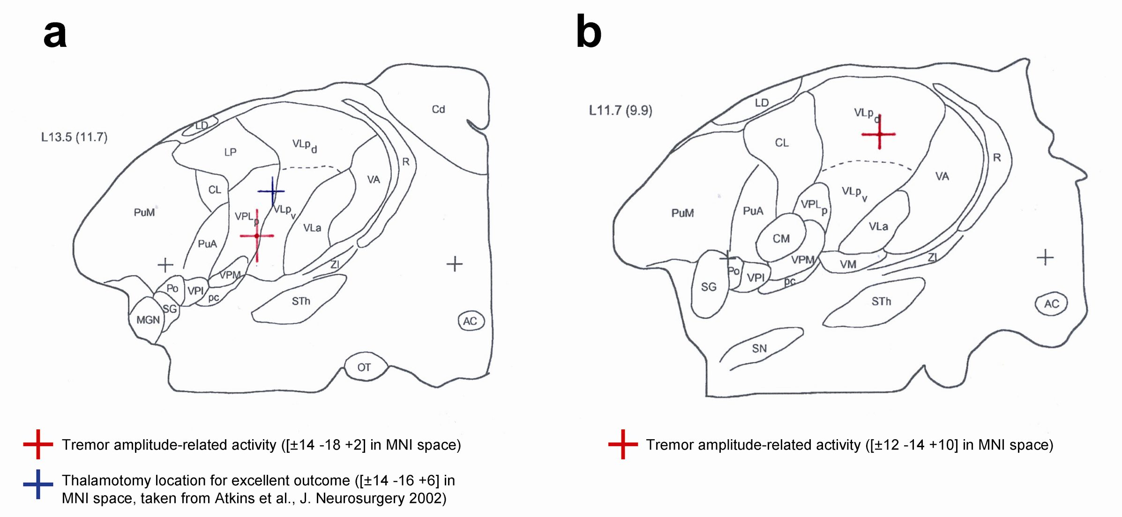

Suppl. Fig. 1: Anatomical location tremor-related activity in the thalamus
Two coronal slices through the human thalamus (13.5 and 11.7 mm from the midline) are shown, taken from the stereotactic atlas by Morel et al. ¹³ The nomenclature of thalamic nuclei is by Jones ¹⁰. The two black crosses indicate the anterior (right) and posterior (left) commissures. The distance between the two black crosses is 25 mm in vivo. In panel A, the red cross indicates the location of the first local maximum of the thalamic cluster displaying tremor amplitude-related activity in PD (MNI coordinates: [±14 -18 +2], see Table 2). The blue cross shows the location of the thalamic region where VIM thalamotomy was shown to optimally reduce tremor in PD ¹². The distance between both locations is 4.5 mm. In panel B, the red cross indicates the location of the second local maximum of the thalamic cluster displaying tremor amplitude-related activity in PD (MNI coordinates: [±12 -14 +10]). The distance between this location and the blue cross from pnel A is 4.7 mm. On the basis of these data, we localize the thalamic tremor-related activity to the VIM region (VLp according to Jones).

- Tremor-related signals (electromyography; EMG)
EMG during scanning was collected in 19 tremor-dominant patients, 23 non-tremor patients, and in 23 of 36 healthy subjects. We used a pair of carbon wired MRI compatible sintered silver/silver-chloride electrodes (Easycap, Herrsching-Breitbrunn, Germany), placed 3 cm apart along the muscle bellies of the forearm muscles (flexor or extensor, depending on the tremor characteristics) of the most-affected arm (PD patients) or the right arm (healthy controls). A neutral electrode was placed on the head of the ulna. Following amplification and A/D conversion (Brain Products GmBH, Gilching, Germany), an optical cable fed the EMG signal to a dedicated PC outside the MR room for further off-line analysis. A hardware filter with 250 Hz low-pass filter and a 10 s time constant was applied before amplification of the signals, after which the EMG was digitized at 5000 Hz. MR artifact correction followed the method described by ^{14,15}. After MR artifact correction the data was down-sampled to 1000 Hz, band-pass filtered (allowing frequencies between 25 and 250 Hz, to remove possible movement artifacts) and rectified to enhance the information on EMG burst-frequency (tremor) of the signal, thereby recovering the low frequency EMG content ¹⁶. Subsequent analyses were performed in Matlab (MathWorks, Natick, MA), consisting of a time-frequency analysis on the preprocessed EMG data using the FieldTrip toolbox for EEG/MEG analysis (http://www.ru.nl/neuroimaging/fieldtrip). For each segment, we calculated the EMG power between 0.5 – 12 Hz in steps of 0.1 s using 2 s Hanning tapered windows, which resulted in a 0.5 Hz resolution. By averaging over all time-points we obtained an average power spectrum across segments. The peak frequency between 2 and 8 Hz. [i.e. the frequency corresponding to the parkinsonian tremor; ¹⁷] was determined for each individual patient after visual inspection of the patient-specific power spectrum. The average power spectrum of each group is shown in Suppl. Fig. 1 (below): there is a clear peak at 4.5 Hz in the tremor-dominant group, but not in the other two groups. Then, EMG power at the individual tremor frequency was extracted and log-transformed. This produced a regressor describing the scan-by-scan fluctuations in EMG power at the tremor frequency (EMG AMP). We also calculated the first temporal derivative of this regressor, which describes the scan-to-scan changes in tremor amplitude (EMG ON/OFFSET). Last, we applied a z-transformation to each of these two regressors and convolved them with the hemodynamic response function (hrf) as implemented in SPM5 (http://www.fil.ion.ucl.ac.uk/spm). By entering these two regressors of interest in a multiple regression analysis, we could test for tremor-related cerebral responses (see manuscript).

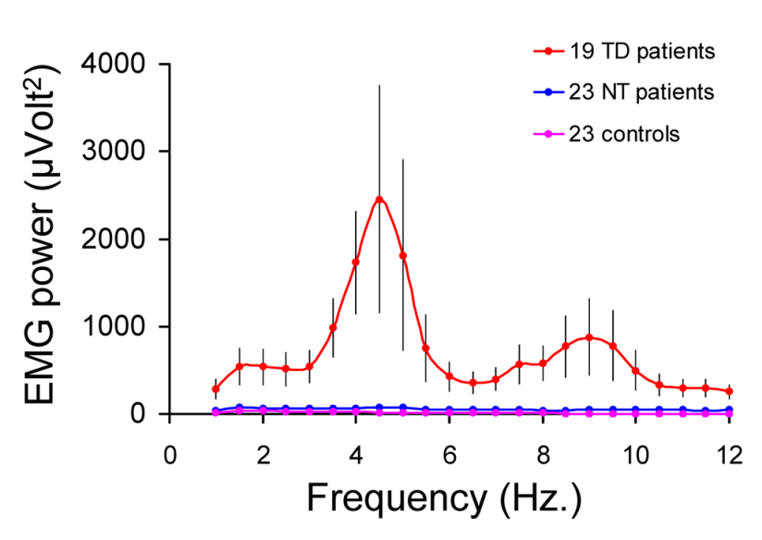

Suppl. Fig. 2: Frequency content of EMG signal collected during scanning
This figure shows the rectified EMG power (y-axis) as a function of frequency (x-axis), averaged (± SEM) over 19 tremor-dominant PD patients (in red), 23 non-tremor PD patients (in blue) and 23 controls (in violet). While the tremor-dominant group PD showed EMG bursts at a frequency of ~4.5 Hz, this pattern was absent for the other two groups. The scan-by-scan fluctuations in EMG power at the tremor frequency of each tremor-dominant PD patient was used to calculate the tremor amplitude (EMG AMP) and tremor onset/offset (EMG ON/OFFSET) regressors shown in Figure 1.

- Functional connectivity within the VIM-MC-CBLM circuit of healthy subjects
In the 36 controls, we extracted the time courses of the left and right VIM (using MarsBaR, http://marsbar.sourceforge.net). To increase the specificity of this analysis, we took the time course of a 4 mm sphere around the local maximum (MNI coordinates: [± 14 -18 +2], see Table 2) of the VIM cluster displaying tremor amplitude-related activity in PD patients. Then we entered these regressors into two separate multiple regression analyses, together with several nuisance regressors (see Methods section under “Tremor-related activity” in the main text). All regressors were low-pass filtered (cut-off frequency at 0.1 Hz) before inclusion into the model. At the second level, we searched for functional coupling between the VIM and the other two regions of the tremor circuit (left/right MC and left/right CBLM). This was done using repeated measures ANOVA with factors LATERALITY-SEED (left VIM, right VIM) and LATERALITY-ROI (left, right), separately for the MC and for the CBLM. The results from this region of interest analysis are shown in Suppl. Fig. 3 panels B (MC) and C (CBLM). We also performed a whole-brain search for VIM connectivity (at a statistical threshold of p<0.05 FWE-corrected). In SPM5, we entered the contrast images of all 36 controls into an ANOVA with factor “SEED” (left VIM, right VIM). The results from this whole-brain analysis are shown in Suppl. Table 1 (below) and in Suppl. Fig. 5A (below).

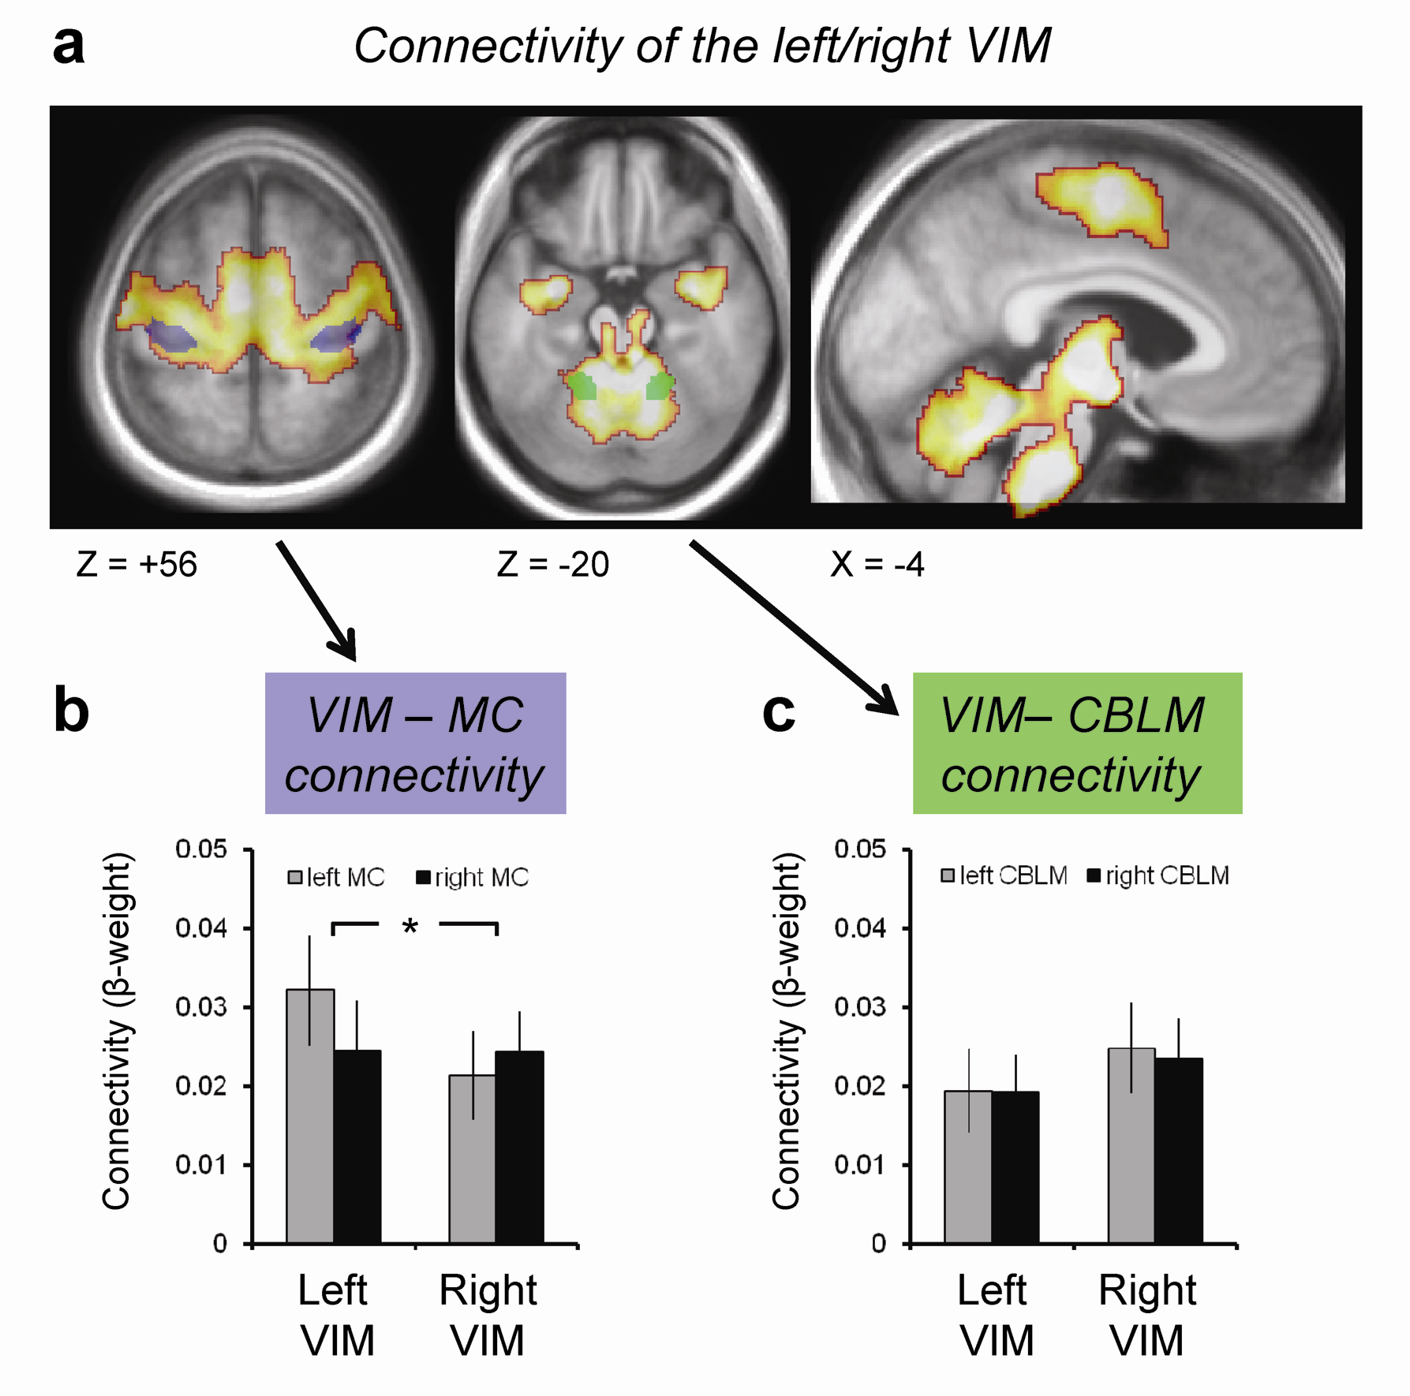
Suppl. Fig. 3: Functional connectivity of the VIM in healthy subjects
This figure shows the pattern of functional connectivity of the left and right VIM in 36 healthy subjects. Panel A shows cerebral activity that was correlated with the left/right VIM (SPM T-contrast on 36 functional connectivity maps), shown at a statistical threshold of p<0.001 uncorrected (for graphical purposes), and overlaid onto the average normalized structural MRI scan of the 36 subjects. Panel A also shows the regions displaying tremor-related activity in PD, i.e. the motor cortex (MC, in blue) and the cerebellum (CBLM, in green). Panels B and C show the connectivity strength (on the y-axis, mean ß-value ± SEM) between the left and right VIM (seed region, on the x-axis) and the left and right MC (colored bars in panel B) or CBLM (panel C). The connectivity strength between VIM and MC was modulated by the laterality of the regions [interaction between LATERALITY-SEED (left VIM, right VIM) and LATERALITY-ROI (left MC, right MC): F(1,35)=13.9; p=0.001]. This interaction was not significant for the CBLM (F<1). These results show strong inter-regional coupling in the VIM-MC-CBLM circuit of healthy subjects, an indication that this circuit is already present in the physiological state. Other regions showing functional connectivity with the bilateral VIM include the premotor cortex and the lower brainstem (inferior olive).

Whole Brain Search (left / right VIM)

Functional Region | Hemisphere | T-value | p-value | Local maximum
 |  |  | (FWE-corr) | x | y | z
Premotor cortex | L | 8.6 | <0.001 | -32 | -16 | 42
 | R | 7.3 | <0.001 | 3 | -12 | 42
SMA | L | 7.0 | <0.001 | -6 | -8 | 58
 | R | 5.8 | <0.001 | 8 | -2 | 56
Lentiform nucleus | L | 9.2 | <0.001 | -26 | 6 | 12
 | R | 8.6 | <0.001 | 2 | 6 | 8
Medulla (inferior olive) | B | 10.4 | <0.001 | 2 | -30 | -40
ROI analyses (left VIM)

Region of Interest | Left Hemisphere |  | Right Hemisphere |  | Left > Right Hemi
 | T-value | p-value | T-value | p-value | T-value | p-value
MC | 4.6 | <0.001 | 3.8 | <0.001 | 2.0 | 0.028
CBLM | 3.7 | <0.001 | 4.1 | <0.001 | 0.025 | 0.49
ROI analyses (right VIM)

 | T-value | p-value | T-value | p-value | T-value | p-value
MC | 3.8 | <0.001 | 4.7 | <0.001 | -0.74 | 0.23
CBLM | 4.4 | <0.001 | 4.7 | <0.001 | 0.41 | 0.34

Suppl. Table 1: Functional connectivity of the VIM in healthy subjects
This table lists the brain regions showing significant functional coupling with the VIM in the healthy control group (n=36). The top section of the table shows the results of a whole-brain random effects analysis (t-contrast over the combined left and right VIM regressors, see Suppl. Figure 3A). At this threshold, there were no brain regions where functional connectivity with the VIM in one hemisphere was larger than with the contralateral VIM. The middle and bottom sections show the results of an ROI analysis in the MC and CBLM (one-sample t-tests, one-tailed; see Suppl. Figure 3B-C). This analysis was done separately for the left VIM (middle section) and for the right VIM (bottom section). For each seed region (left VIM, right VIM), we also tested for stronger connectivity with the MC/CBLM in the ipsilateral hemisphere than in the contralateral hemisphere (using paired-samples t-tests, one-tailed).

- Imaging of the dopamine transporter (DaT)
Image acquisition: 35 PD patients (16 tremor-dominant and 19 non-tremor) received a presynaptic dopamine transporter (DaT) scan on a separate day within three months after the fMRI scan. Cerebral SPECT imaging was performed three hours after intravenous injection of 185 MBq [I-123]FP-CIT (DaTscan, GE Healthcare, Eindhoven, The Netherlands) with a dual headed gamma camera (Siemans ECAM, Siemens AG, Erlangen, Germany). All scans were performed with the same camera, especially calibrated for DaT-scanning using a dedicated phantom as supplied by the manufacturer. The transaxial resolution described by the full-width at half-maximum (FWHM) of this camera is ≤ 8.4 mm after reconstruction. The camera was fitted with low-energy high-resolution collimators using a 15% energy window centered on the 159 keV photon energy-peak of iodine-123. Both heads performed a 180 degree circular motion and collected 64 projections (40 seconds per view) in a step-and-shoot mode using a 128 x 128 matrix with a zoom factor of 1.23. During scanning the patient’s head was positioned in a head rest and the patient’s head and shoulders were fixated to minimize movement during the scan. The radius of the detector orbit was kept as small as possible. Transaxial images were reconstructed using filtered back projection with post-reconstruction filtering (Butterworth 8th order, cutoff 0.6) without attenuation correction. Registration and semi quantitative analysis were performed with a workstation (HERMES, Nuclear Diagnostics, Stockholm, Sweden).

DaT Image pre-processing: First, we co-registered each subject’s DaT image to his or her structural MRI scan, normalized the structural MRI scan to MNI space [using unified segmentation; (Ashburner and Friston, 2005)] and applied the resulting normalization parameters to the DaT image, while correcting for volume changes induced by normalization. Second, we estimated the proportion of the signal caused by specific DaT binding (as opposed to activity caused by unbound or non-specifically bound FP-CIT). We followed the method described by Scherfler and colleagues ¹⁹, which involves normalizing each voxel’s raw signal (VT) by the signal in a region that is devoid of dopamine transporters (the occipital cortex, V₂). In more detail, for each voxel we calculated the specific-to-nondisplaceable equilibrium partition coefficient (V”₃), which is proportional to DaT density (B_{max}) and can be calculated according to the equilibrium model introduced by Laruelle and colleagues ²⁰. Under equilibrium conditions between a compartment with specific binding and a compartment representing non-specifically bound and free activity, V”₃ is proportional to B_{max} given that both the dissociation constant and the volume of distribution of the V₂ compartment is relatively invariant in the population. Under the assumption that the occipital region is devoid of dopamine transporters, the parameter V”₃ can be computed for every voxel using the formula:

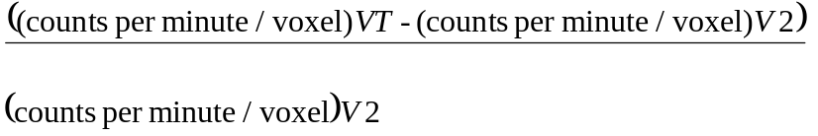

Calculation of striato-pallidal DaT binding: the procedure outlined above resulted in one V”₃ image for each subject, normalized to MNI space. We used this image to calculate the average amount of DaT binding in three basal ganglia regions: the pallidum, putamen and caudate nucleus. This was done separately for the least- and for the most-affected hemisphere. We individually defined these regions for each patient, by applying an automated segmentation tool implemented in FSL [FIRST v1.1; www.fmrib.ox.ac.uk/fsl] to each subject’s normalized structural MRI scan. This resulted in subject-specific segmented images of the left and right pallidum, putamen and caudate nucleus. We overlaid these six images onto each subject’s V”₃ image, and calculated the average V”₃ value for each region. By using patient-specific anatomical regions of interest, we avoided spatial smoothing of DaT (V”₃) images that is normally done to accommodate inter-individual anatomic variability ¹⁹. This was particularly relevant for the present study, because we wanted to spatially separate dopamine binding in the pallidum (where we expected tremor-related effects ^{21,22}) from that in the neighboring putamen (where we did not expect tremor-related effects ^{23,24}). Furthermore, by using a procedure that accounts for inter-individual differences in subcortical anatomy, we expected to increase the reliability and sensitivity of our analyses as compared to procedures that use standard striatal templates ²⁴. Finally, we compared these striato-pallidal values across groups and across hemispheres using ANOVA, and we correlated them with clinical disease severity scores using Pearson correlations (see manuscript).

Specificity of the findings to the DaT: Since [I-123]FP-CIT binds not only to the dopamine transporter (DaT), but also to the serotonin transporter (SERT), it might be argued that the pallidal SPECT effects are driven by serotonergic instead of dopaminergic effects. There are several arguments that make this possibility highly unlikely. First, neuro-anatomical studies in primates show that the dopaminergic innervation of the pallidum is much denser than the serotonergic innervation ²⁵. This indicates that the pallidal density of DaT is higher than that of SERT. Second, a post-mortem study in PD patients ²¹ and an animal study in parkinsonian primates ²² have shown similar correlations between pallidal dopamine depletion and tremor severity as reported here. Crucially, in these studies more direct measures of dopamine were used, i.e. a dopamine metabolite [homovanillic acid, HVA; ²¹] and tyrosine hydroxylase (TH), an enzyme that converts the amino acid L-tyrosine to DOPA ²². This indicates that resting tremor severity is closely linked to pallidal concentrations of dopamine. Third, the isotope used here ([I-123]FP-CIT) has a 10 times higher affinity for the DaT than for the SERT ²⁶. This indicates that the SPECT signal reported here predominantly reflects DaT (not SERT) density. Finally, the chosen temporal interval between injection of the isotope and performance of the SPECT scan (three hours) is optimized for imaging the DaT, but not the SERT [which has optimal binding with the isotope ~one hour after injection ²⁶]. Together, these considerations strongly argue that the effects we observe are driven by dopaminergic, not serotonergic, mechanisms.

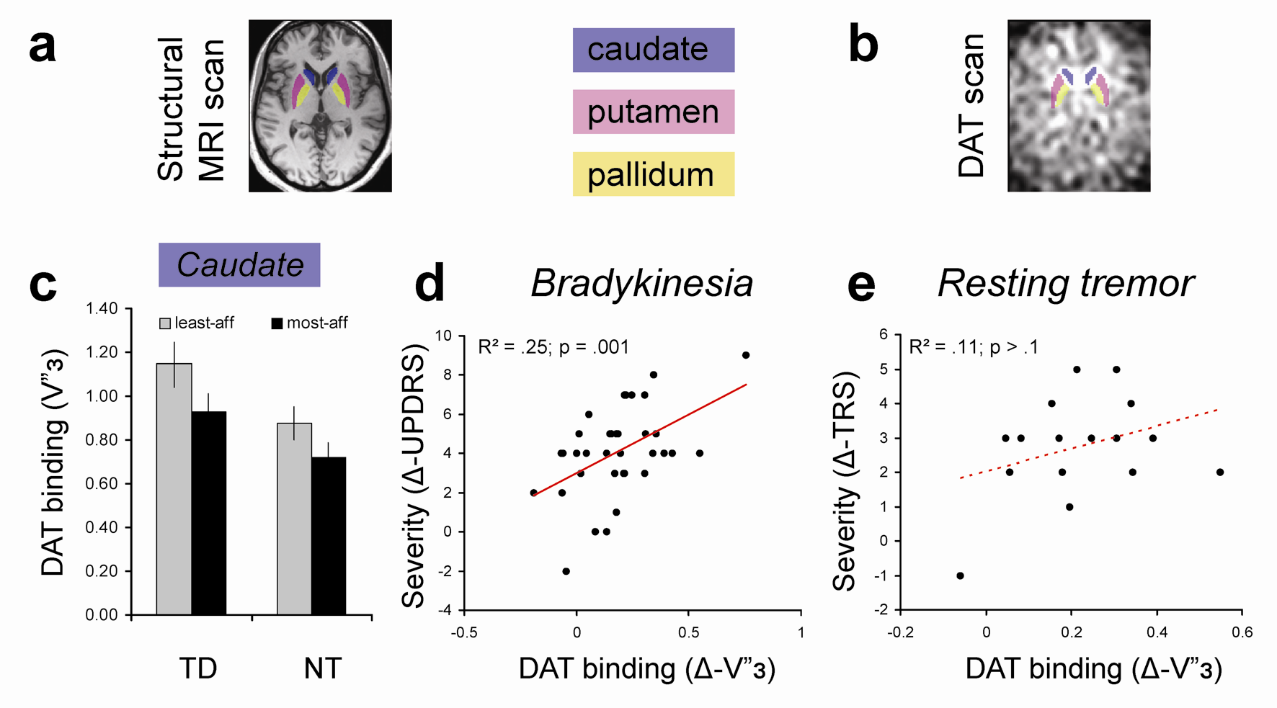

Suppl. Fig. 4: Imaging of the dopamine transporter (DaT) in the caudate

This figure shows the amount of pre-synaptic DaT binding (using [I-123]FP-CIT SPECT) in the caudate (panel A, in blue), separately for tremor-dominant (TD) and non-tremor PD patients (NT), and for the most- (black) and least-affected hemisphere (gray). DaT binding for the putamen and pallidum is shown in Figure 3. The caudate was defined based on each patient’s structural MRI scan (panel A). We overlaid these images onto each patient’s SPECT scan (panel B), and calculated the average DaT binding across the whole caudate, separately for each hemisphere. Panel C shows regional DaT binding (on the y-axis, mean V”3 ± SEM) for each PD group and each hemisphere. Panel D shows the correlation between regional DaT binding (on the x-axis, difference between both sides, Δ-V”3) and bradykinesia severity (on the y-axis, difference between both sides, Δ-UPDRS). Panel E shows the correlation between regional DaT binding and resting tremor severity (on the y-axis, difference between both sides, Δ-TRS). These data show that dopamine depletion in the caudate (and the putamen) explains the severity of bradykinesia, but not tremor. Abbreviations as in Figure 3.

References

1. Wenzelburger R, Zhang BR, Pohle S et al. Force overflow and levodopa-induced dyskinesias in Parkinson's disease. Brain. 2002; 125:871-879
2. Friston KJ, Ashburner J, Frith CD et al. Spatial registration and normalization of images. Human Brain Mapping. 1995; 3:165-189
3. Ashburner J, Friston KJ. Unified segmentation. Neuroimage. 2005; 26:839-851
4. Ashburner J, Friston K. Multimodal image coregistration and partitioning - A unified framework. Neuroimage. 1997; 6:209-217
5. Cordes D, Haughton VM, Arfanakis K et al. Frequencies contributing to functional connectivity in the cerebral cortex in "resting-state" data. AJNR Am J Neuroradiol. 2001; 22:1326-1333
6. Fox MD, Raichle ME. Spontaneous fluctuations in brain activity observed with functional magnetic resonance imaging. Nat Rev Neurosci. 2007; 8:700-711
7. Lund TE, Norgaard MD, Rostrup E et al. Motion or activity: their role in intra- and inter-subject variation in fMRI. Neuroimage. 2005; 26:960-964
8. Maldjian JA, Laurienti PJ, Kraft RA et al. An automated method for neuroanatomic and cytoarchitectonic atlas-based interrogation of fMRI data sets. Neuroimage. 2003; 19:1233-1239
9. Eickhoff SB, Stephan KE, Mohlberg H et al. A new SPM toolbox for combining probabilistic cytoarchitectonic maps and functional imaging data. Neuroimage. 2005; 25:1325-1335
10. Hirai T, Jones EG. A new parcellation of the human thalamus on the basis of histochemical staining. Brain Res Brain Res Rev. 1989; 14:1-34
11. Hassler R. Architectonic organization of the thalamic nuclei. In: Walker AE, ed. Stereotaxy of the Human Brain. Anatomical, Physiological and Clinical Applications. New York: Georg Thieme Verlag, 1982
12. Atkinson JD, Collins DL, Bertrand G et al. Optimal location of thalamotomy lesions for tremor associated with Parkinson disease: a probabilistic analysis based on postoperative magnetic resonance imaging and an integrated digital atlas. J Neurosurg. 2002; 96:854-866
13. Morel A, Magnin M, Jeanmonod D. Multiarchitectonic and stereotactic atlas of the human thalamus. J Comp Neurol. 1997; 387:588-630
14. Allen PJ, Josephs O, Turner R. A method for removing imaging artifact from continuous EEG recorded during functional MRI. Neuroimage. 2000; 12:230-239
15. van Duinen H, Zijdewind I, Hoogduin H et al. Surface EMG measurements during fMRI at 3T: accurate EMG recordings after artifact correction. Neuroimage. 2005; 27:240-246
16. Myers LJ, Lowery M, O'Malley M et al. Rectification and non-linear pre-processing of EMG signals for cortico-muscular analysis. J Neurosci Methods. 2003; 124:157-165
17. Deuschl G, Raethjen J, Lindemann M et al. The pathophysiology of tremor. Muscle Nerve. 2001; 24:716-735
18. Cole DM, Smith SM, Beckmann CF. Advances and pitfalls in the analysis and interpretation of resting-state FMRI data. Front Syst Neurosci. 2010; 4:8
19. Scherfler C, Seppi K, Donnemiller E et al. Voxel-wise analysis of [123I]beta-CIT SPECT differentiates the Parkinson variant of multiple system atrophy from idiopathic Parkinson's disease. Brain. 2005; 128:1605-1612
20. Laruelle M, Wallace E, Seibyl JP et al. Graphical, kinetic, and equilibrium analyses of in vivo [123I] beta-CIT binding to dopamine transporters in healthy human subjects. J Cereb Blood Flow Metab. 1994; 14:982-994
21. Bernheimer H, Birkmayer W, Hornykiewicz O et al. Brain dopamine and the syndromes of Parkinson and Huntington. Clinical, morphological and neurochemical correlations. J Neurol Sci. 1973; 20:415-455
22. Mounayar S, Boulet S, Tande D et al. A new model to study compensatory mechanisms in MPTP-treated monkeys exhibiting recovery. Brain. 2007; 130:2898-2914
23. Pirker W. Correlation of dopamine transporter imaging with parkinsonian motor handicap: how close is it? Mov Disord. 2003; 18 Suppl 7:S43-S51
24. Spiegel J, Hellwig D, Samnick S et al. Striatal FP-CIT uptake differs in the subtypes of early Parkinson's disease. J Neural Transm. 2007; 114:331-335
25. Charara A, Parent A. Brainstem dopaminergic, cholinergic and serotoninergic afferents to the pallidum in the squirrel monkey. Brain Res. 1994; 640:155-170
26. Booij J, de Jong J, de Bruin K et al. Quantification of striatal dopamine transporters with 123I-FP-CIT SPECT is influenced by the selective serotonin reuptake inhibitor paroxetine: a double-blind, placebo-controlled, crossover study in healthy control subjects. J Nucl Med. 2007; 48:359-366

